IFT 166 Introduction to Internet Networking
Lab 7
Peer-to-Peer, Hub & Switch based LANs

After you complete each step, put a ‘√’ or ‘x’ in the completed box
Build a Peer-to-Peer Network

Objectives: create a simple peer-to-peer network. Identify the proper cable to connect the two PCs. Configure workstation IP address information. Test connectivity using the Ping command.

- Setup the following topology
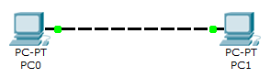

What type of cable did you use for the connection and why?

- Configure the PCs with the following IP address information

- All machines on the same LAN should share the same network portion
- You do not need the default gateway IP address as these computers are directly connected. You only need the default gateway on LANs that are connected to a router
- Confirm your TCP/IP network settings via ipconfig command

- Verify that the PCs can communicate via the ping command


Build a Hub Based Network
Objectives: create a simple network with 2 PCs using a hub. Identify the proper cable to connect the two PCs to the hub. Configure workstation IP address information. Test connectivity using the Ping command.

- Setup the following topology

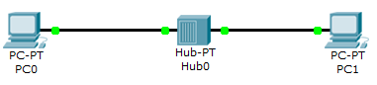

What type of cable did you use for the connections and why?

- Configure the PCs with the following IP address information

- Confirm your TCP/IP network settings via ipconfig command

- Verify that the PCs can communicate via the ping command

Build a Switch Based Network
Objectives: create a simple network with 2 PCs using a switch. Identify the proper cable to connect the two PCs to the Switch. Configure workstation IP address information. Test connectivity using the Ping command.

- Setup the following topology

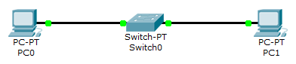

What type of cable did you use for the connections and why?

- Configure the PCs with the following IP address information

- Confirm your TCP/IP network settings via ipconfig command

- Verify that the PCs can communicate via the ping command

Final Scenario

- Setup the following star topology network.
- PC0: 192.168.0.1 255.255.255.0
- PC1: 192.168.0.2 255.255.255.0
- PC2: 192.168.0.3 255.255.255.0
- PC3: 192.168.0.4 255.255.255.0
- Run simulation to show how the packet travels from PC0 to PC3.

